

***CONTAINERS AND DOCKERS***

***Submitted by:***

***NAME: Tanishqua Tellakula***

***SAP ID: 500084269***

***Roll number :R120220007***

***Batch: B1(Hons)***

***Lab Exercise 7- Create Service in Kubernetes***

***Objective:***

* *Understand the syntax and structure of a Kubernetes Service definition file (YAML).*
* *Learn to create different types of Services: ClusterIP, NodePort, and LoadBalancer.*
* *Comprehend how Services operate independently of specific Pods.*

***Prerequisites***

* *Kubernetes Cluster: Have a running Kubernetes cluster (locally using Minikube or kind, or a cloud-based service).*
* *kubectl: Install and configure kubectl to interact with your Kubernetes cluster.*
* *Basic Knowledge of YAML: Familiarity with YAML format will be helpful for understanding Kubernetes resource definitions.*

***Step-by-Step Guide***

***NodePort Service***

*To expose the Service on a port on each Node in the cluster, modify the Service type to NodePort.*

*Create a YAML file named nodeport-service.yaml with the following content:*

|  |
| --- |
| ***apiVersion: v1***  ***kind: Service***  ***metadata:***  ***name: nodeport-service***  ***spec:***  ***selector:***  ***app: my-app***  ***ports:***  ***- protocol: TCP***  ***port: 80***  ***targetPort: 80***  ***nodePort: 30007 # A specific port in the range 30000-32767***  ***type: NodePort*** |

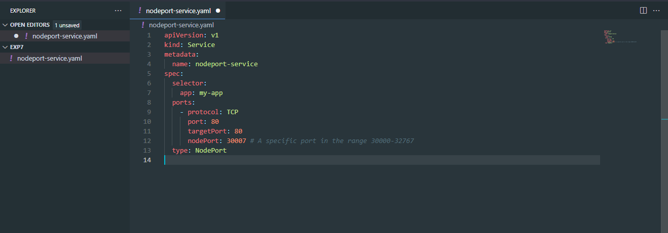

***Explanation:***

* *The primary difference from the ClusterIP Service is the addition of nodePort, which specifies the static port on each Node.*
* *type: Set to NodePort, exposing the Service on a specific port across all Nodes.*

*Apply this YAML to create the NodePort Service:*

|  |
| --- |
| ***kubectl apply -f nodeport-service.yaml*** |

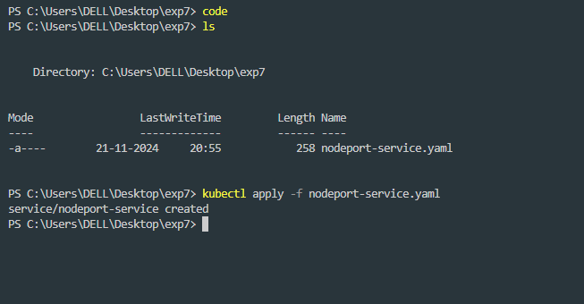

***Verify the Service:***

|  |
| --- |
| ***kubectl get services*** |

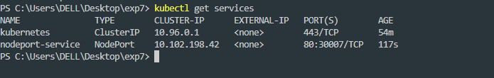

*You should see the nodeport-service listed with a NodePort and details about the port exposed.*